Skill assessment of Data Structure lab:

Attempt any of the 5 Questions in the following:

- Write a C/C++ program to calculate the sum of 2-D array.
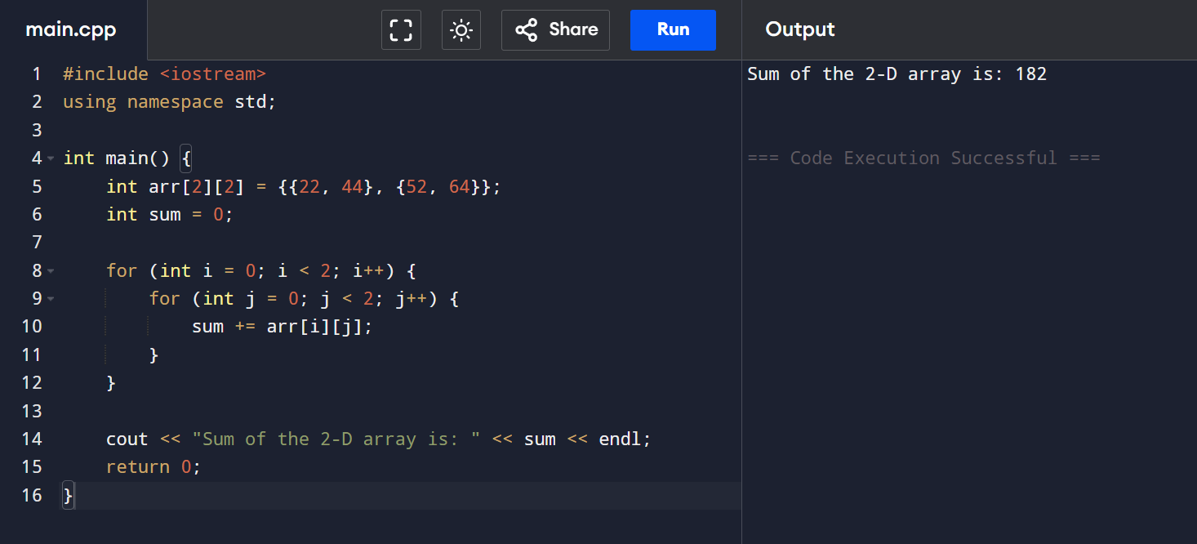
- Write a C/C++ program to find the largest element in the 2-D array.
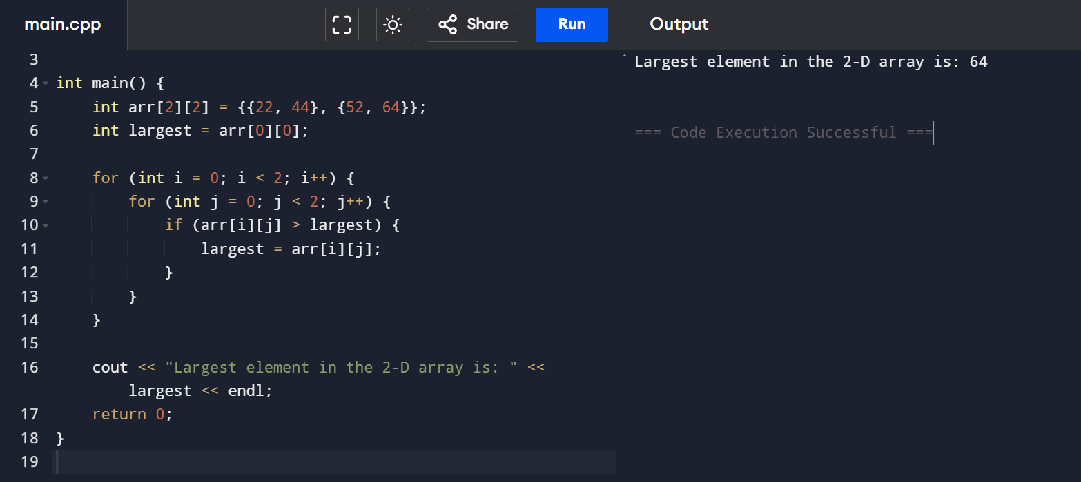

5. Write a C/C++ program to calculate multiplication of the 2-D array.
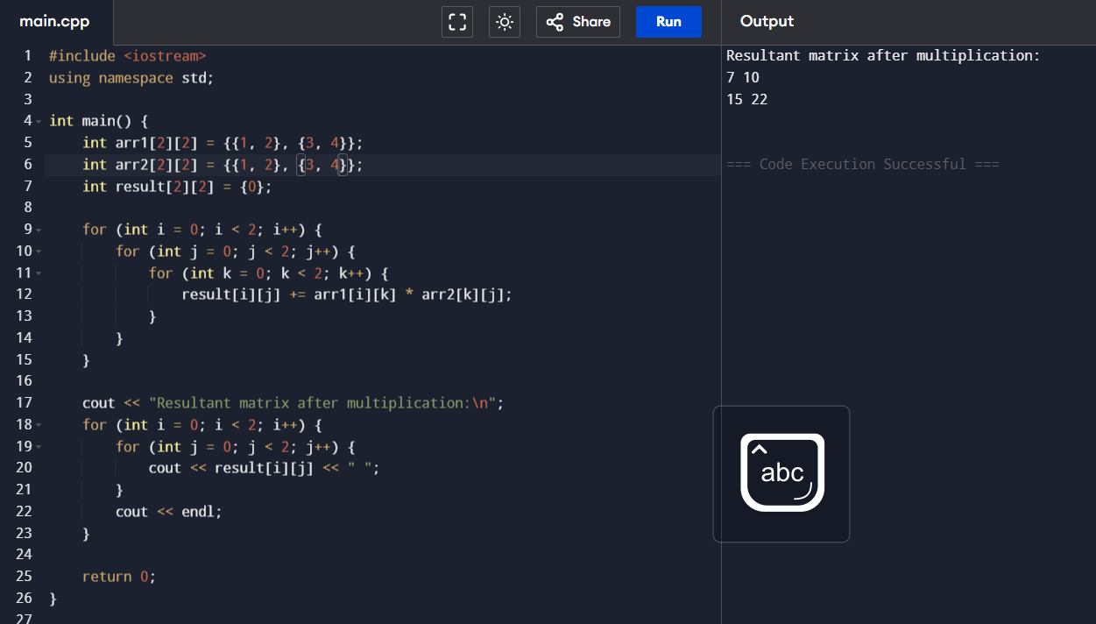
- Write a program in C/C++ that implements Bubble sort sorting methods to sort a given list of integers in ascending order.
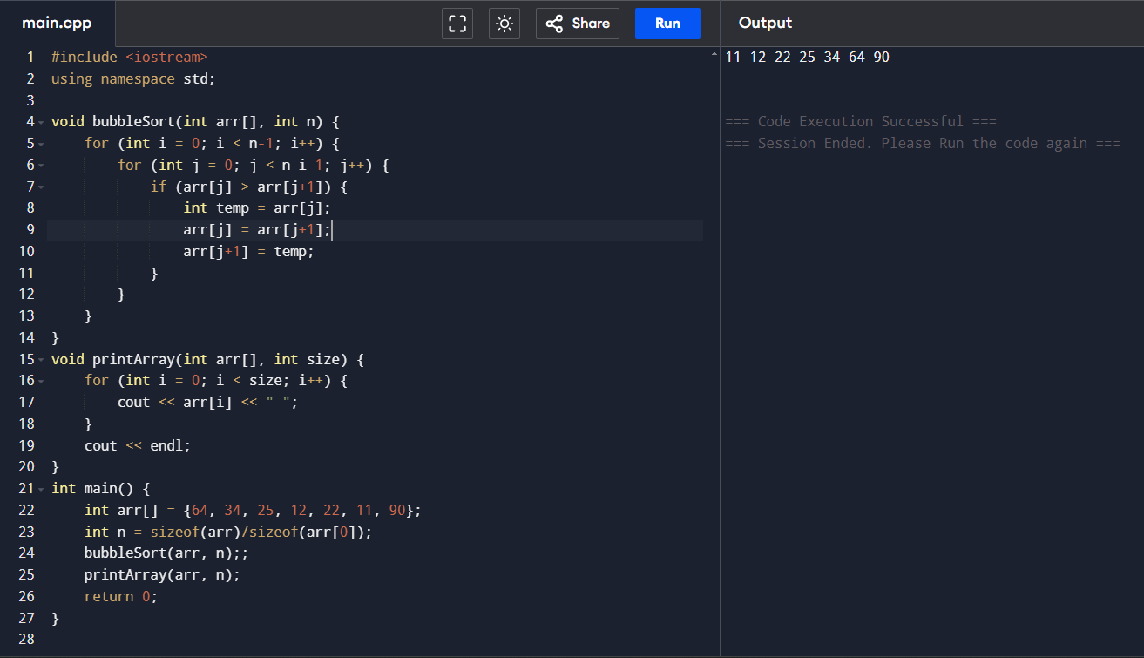

- Write a program in C/C++ that implements selection sort sorting methods to sort a given list of integers in ascending order.

